K Bid Auction Design Document

Author: V Koteswara Rao
28 April2016

1. Introduction

Purpose of this document
This is documentation for the design and technical details description for the K Bid Auction web application development for project evaluation for Cross Over
In this document all the design aspects related to the UI, Database, Architectural and other functions will be given in separate sections.
The application is mainly a web application developed using Angular JS, Node.js with SQlite as db with express js as backend.

2. Architecture Design
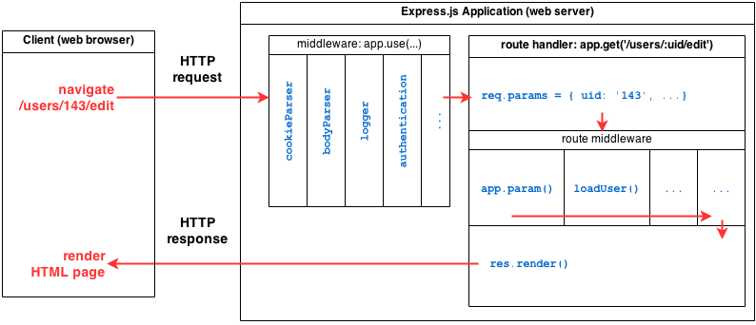
The main architectural design is the design of the entire web application flow can be explained in the above two image. it gives a high-level overview of the components and other frameworks involve.
- Main request initiated from web browser will be HTTP request will be received by expressjs app.use()
- Then the respective app.get will be called to serve the request with respective restful service.
- The restful service return the required response retrieve/queried from the SQLite data base tables.
- Then the response will be send to web browser using res.json/res.sender.

3. Technologies and Frameworks
GUI – HTML5, Bootstrap, CSS
Frond-end – AngularJS, npm packages like(Restangular, angular-ui-bootstrap, ngMockE2E etc..)
Middle ware – Express JS
Server – Node.js
Database – Sqlite3, Sqlite Studio.
Build and deployment – Yomen Scafolding with grunt has been used to maintain an deploy the code

4. Database Design
For data base, SQlite has been used for simple and easy of use with nodejs and express js.
Initial database tables are designed in Sqlite Studio and then using NodeJs and express js the db access code has been maintained.
As a whole 5 tables are created for the K Bid application. The details can be viewed in the below sections.
The names of the tables are intuitive enough to understand the table nature and information of the data

Tables schemas
Table1 - Products
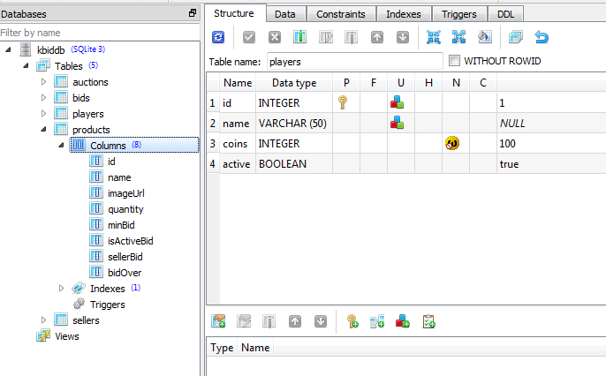
Table2 - Players
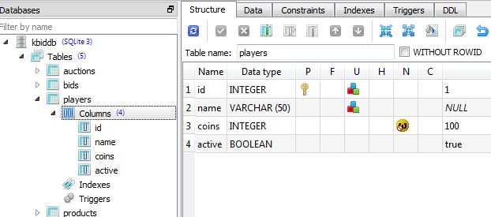
Table3 – auctions
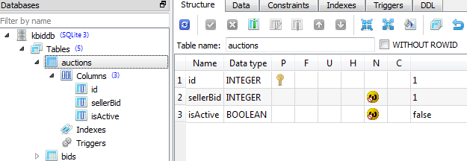

Table4 – bids
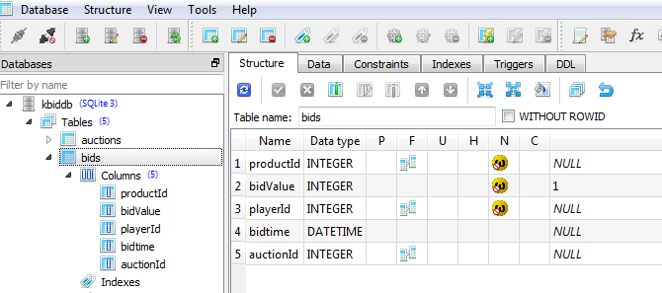
Table5- Sellers
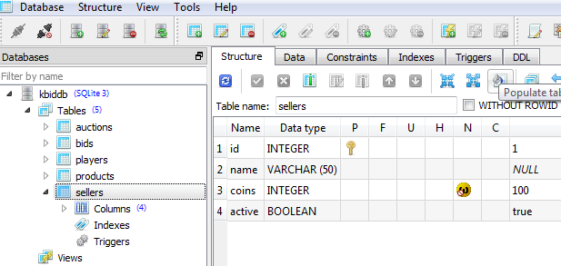

SQL queries:
All the queries are mentioned in the restful services written in nodejs javascript file.
The file name is restsql.jscan the found in the root folder of the zipped source.
Some of the sample queries are like the given below.
var maxPlayerId = 'select max(id) as mid from players';
var maxAuctionQuery = 'select max(id) as amid from auctions';
var playersQuery = "SELECT * from players";
db.run("UPDATE players SET coins="+req.params.coins+" WHERE id = "+req.params.plid, function(err, row){
if (err){
db.run("UPDATE products SET bidOver='"+req.params.bo+"', isActiveBid='false', quantity="+req.params.qty+" WHERE id = "+req.params.id, function(err, row){

….and so on,
All other queries can be found in restsql.js file.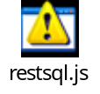

4. Services
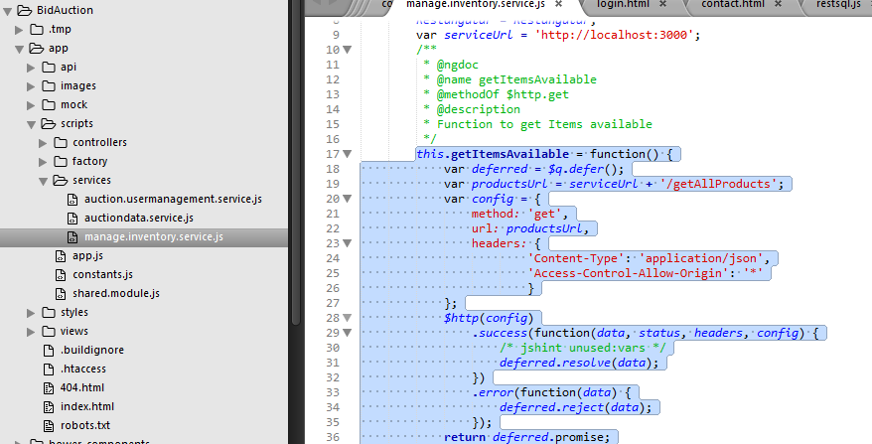

5. Graphical User Interface
The demos can be found in demos folder of the zipped source.
About and Contact screens are empty. Coded just to show the structure
The initial and key screen is Dash board screen after login.
Login screen
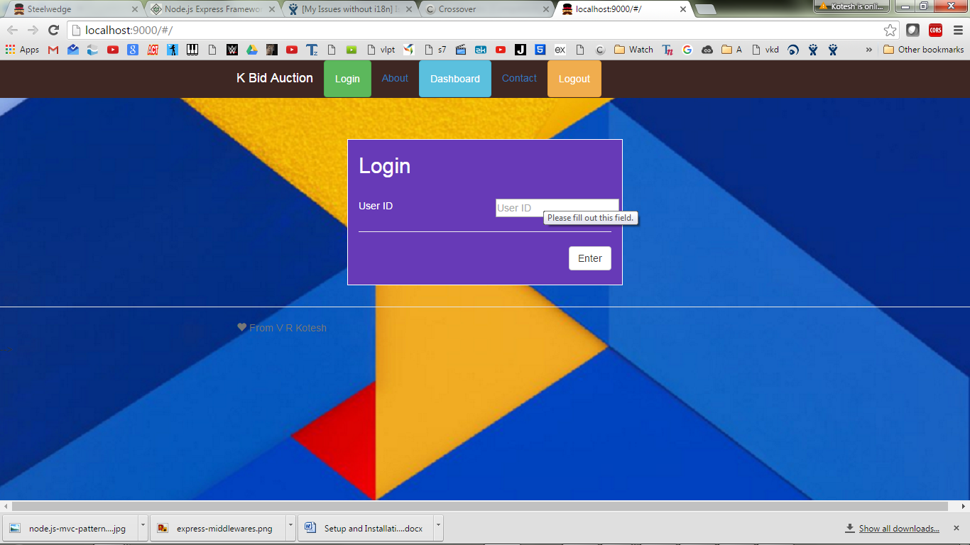
Initial screen-
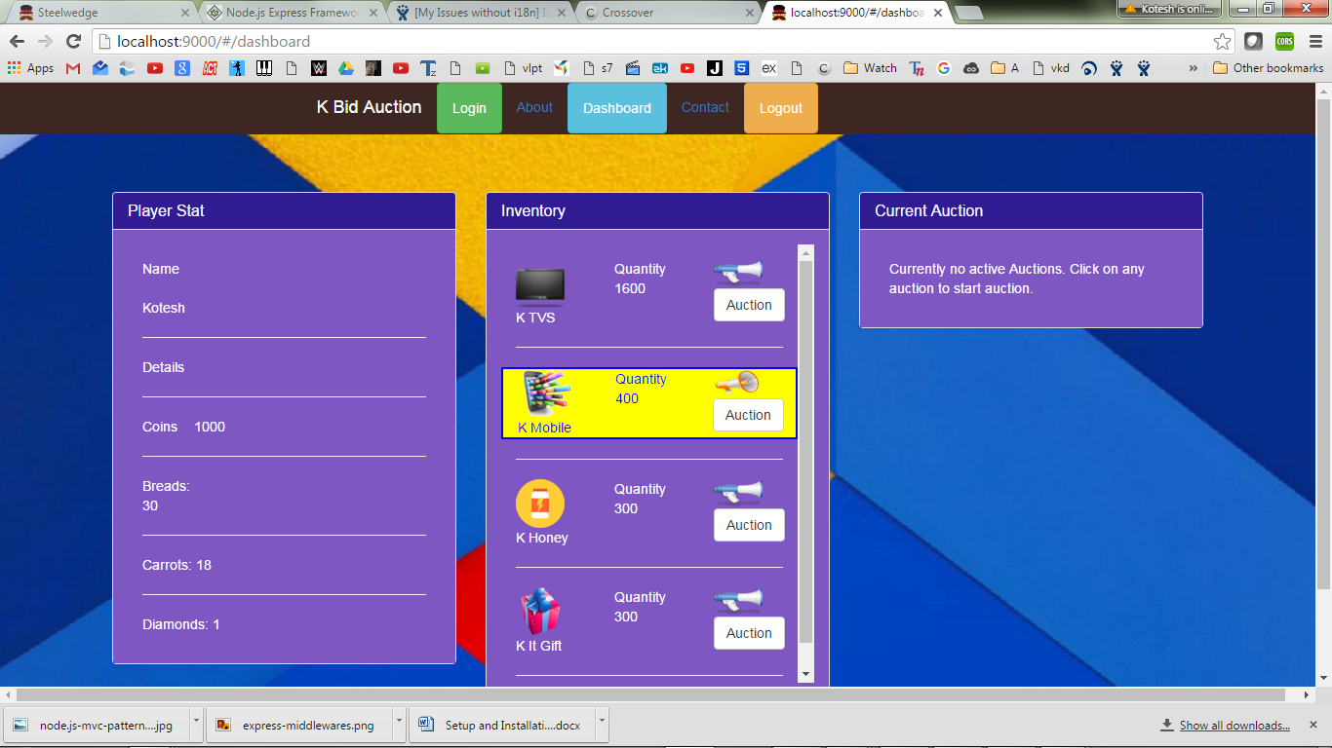
Auction Confirmation
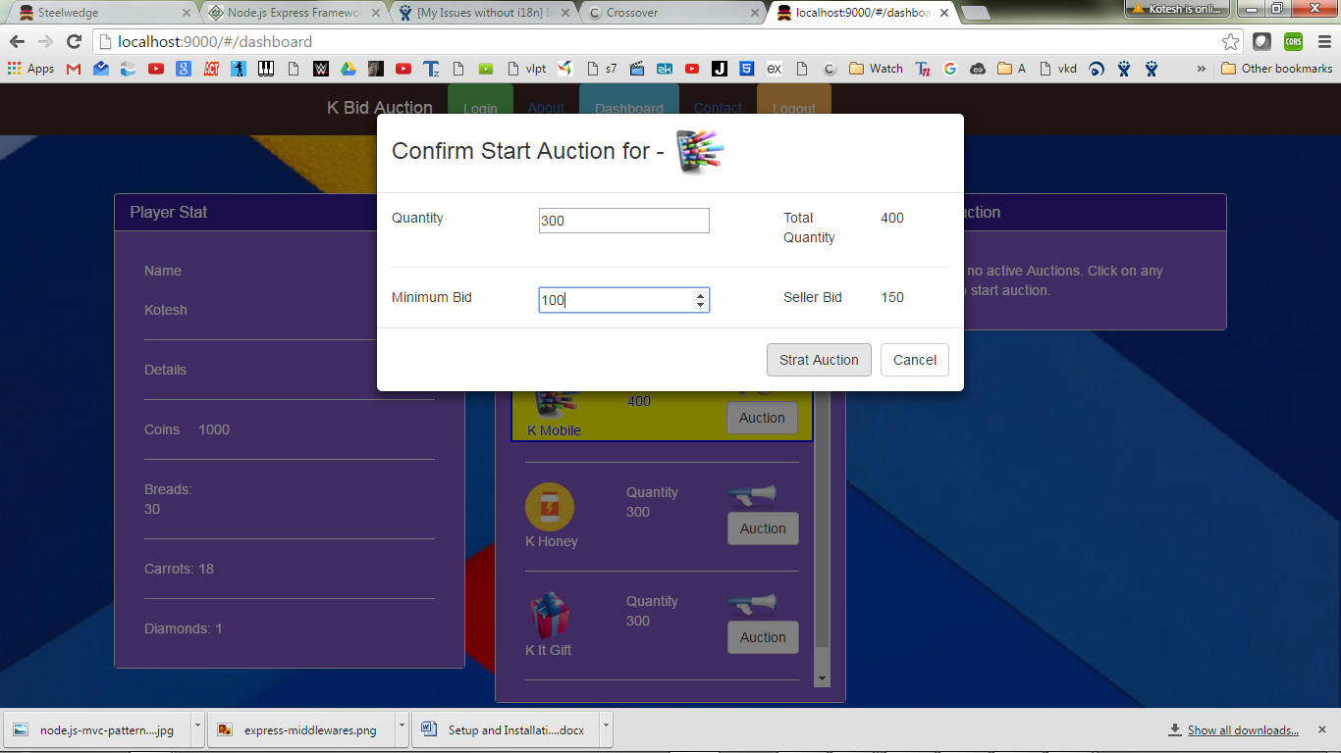
Auction started
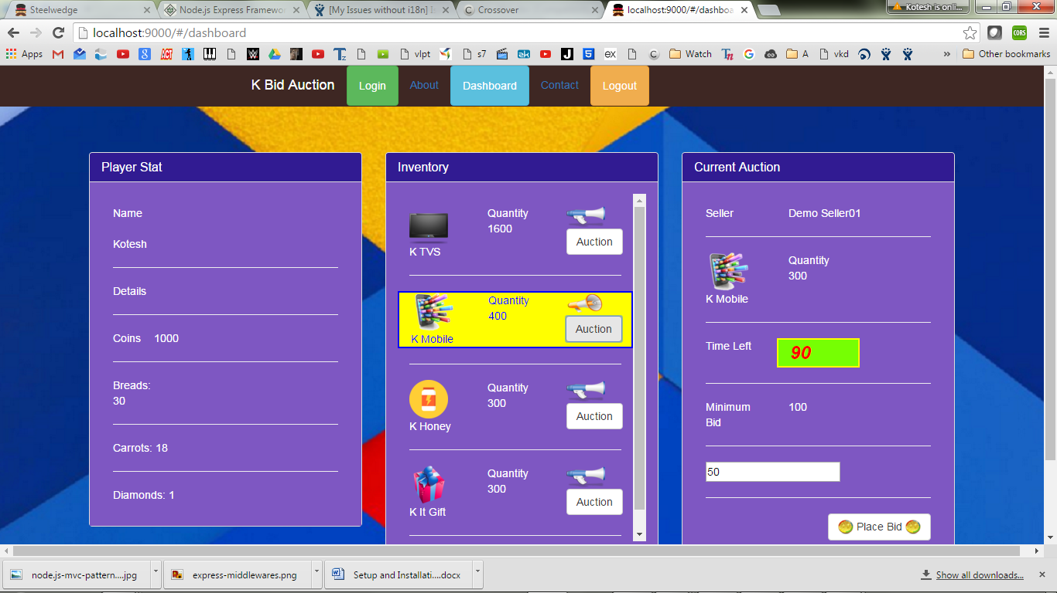
Bid Started.
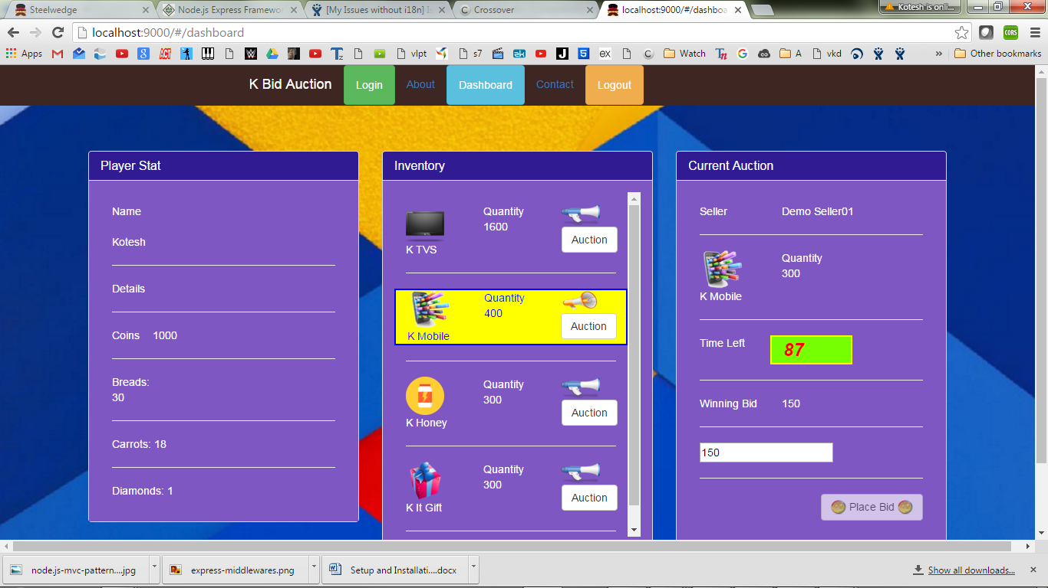
Winning bid screen
